<https://handsonreact.com/docs/labs/ts/YourFirstComponent>

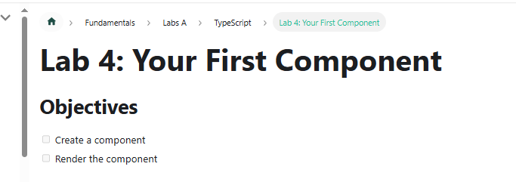

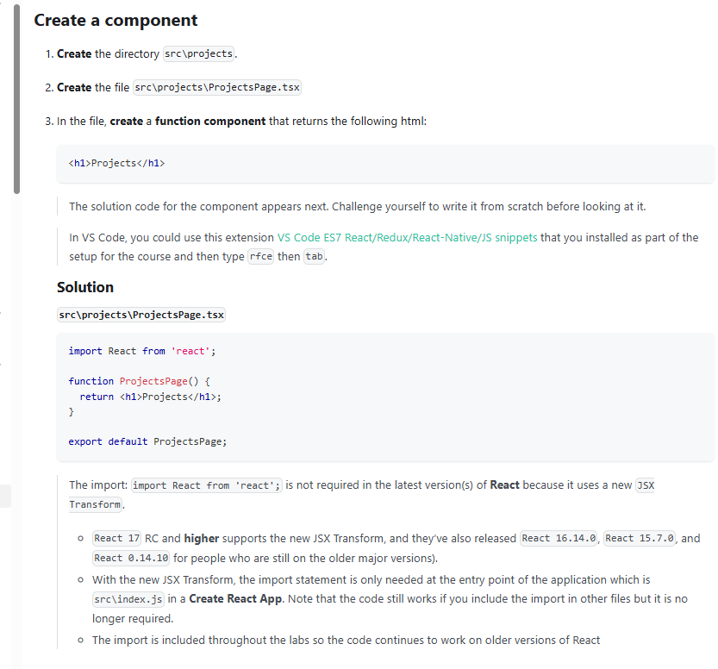

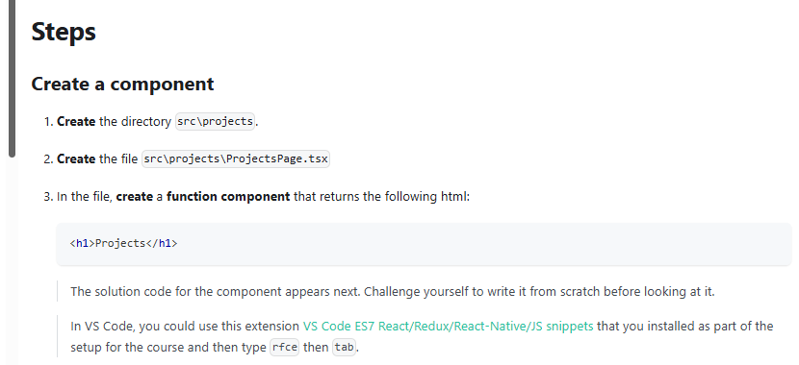

Create a component

1. Create the directory src\projects.
2. Create the file src\projects\ProjectsPage.tsx
3. In the file, create a function component that returns the following html:

<h1>Projects</h1>

The solution code for the component appears next. Challenge yourself to write it from scratch before looking at it. In VS Code, you could use this extension [VS Code ES7 React/Redux/React-Native/JS snippets](https://marketplace.visualstudio.com/items?itemName=dsznajder.es7-react-js-snippets) that you installed as part of the setup for the course and then type rfce then tab.

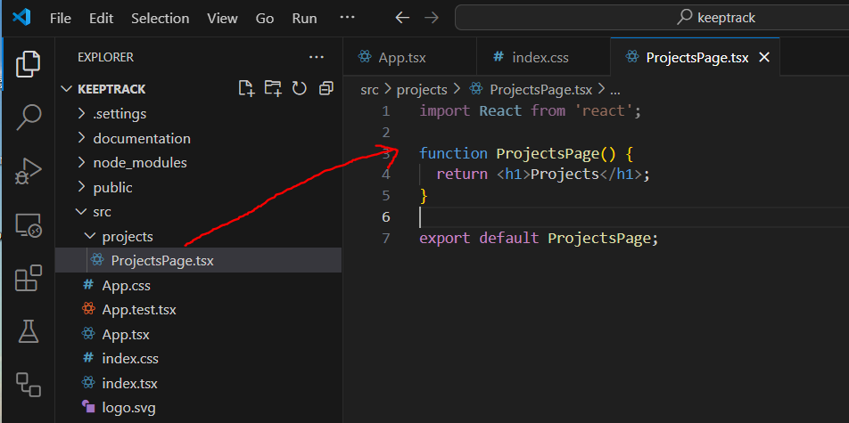

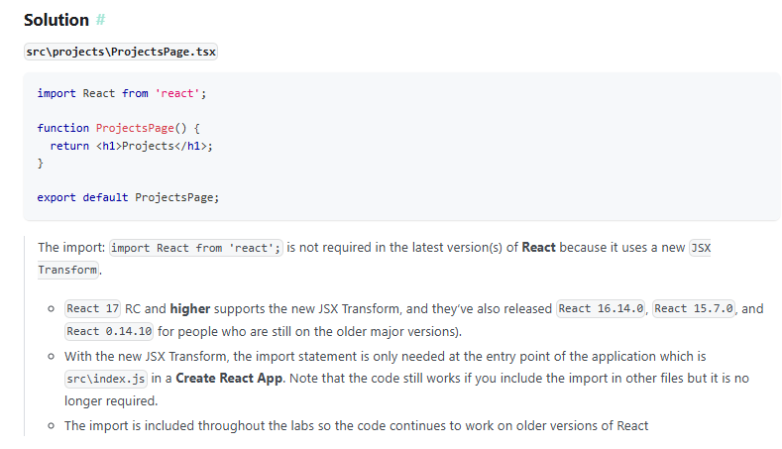

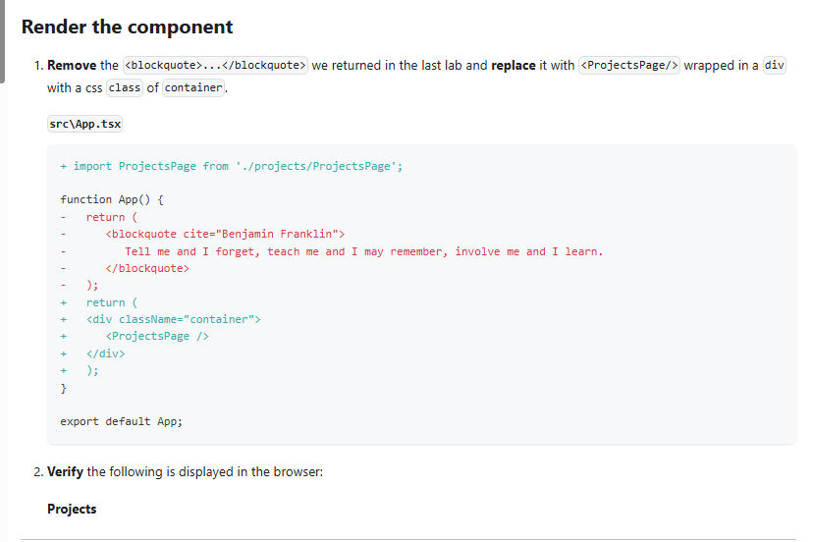

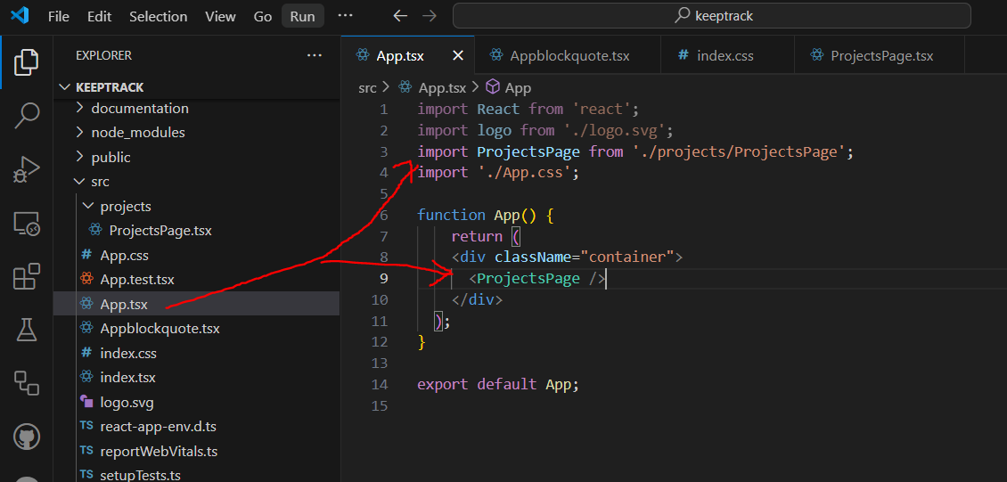

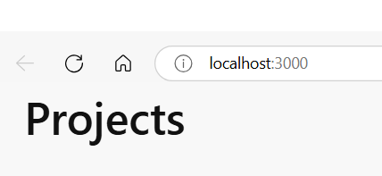 **OK 😊**

